**Protocol title:**

Elders Playing Like Children

**Principal Investigator:**

Alan Cook, MD, MS, FACS

Associate Professor, Department of Epidemiology and Biostatistics

School of Community and Rural Health

University of Texas Health Science Center, Tyler

(903) 941-0229

alan.cook@uthct.edu

adcookmd@gmail.com

**Version Date and Number**:

Version No. 1, January 27, 2020.

**Introduction**:

Between the 2000 US Census and the 2010 Census, the number of persons aged 45 to 64 years increased by 31.5% while those 65 and over increased by 15.1 percent.1 These were the groups who grew the most in that decade. The percentage of the US population age 65 and older is projected to grow from 33.5% to 42.1% over the next 20 years. Improved medical management of chronic diseases is allowing this portion of the population to participate in high risk activities like motorcycling, boating and riding all-terrain vehicles.2 As the US population ages, so does the population undergoing treatment for injuries. Unintentional injury is the seventh leading cause of death of Americans 65 years-old and older. 3

The literature regarding elders sustaining injury while participating in high-risk recreational activities is accumulating but remains limited. We seek to describe the population of elderly patients who are treated for injuries sustained while participating in high risk recreational activities. We will also compare several injury severity-adjusted outcomes of elder patients to younger patients injured in similar mechanisms with similar injuries and similar likelihood of death due to injury.

**Hypothesis/Key Questions**:

1. People are injured in high-risk recreational activities well into their eighth decade of life and beyond (seventy years-old and older)

2. The median severity of injuries among people who present to United States (US) emergency departments (EDs) for injuries sustained while participating in high-risk recreational activities will not differ by age groups.

3. Hospital mortality will differ by age-group within mechanism of injury groups

**Selection of Participants**:

The data will originate from the Nationwide Emergency Department Sample (NEDS), a publicly available dataset available for purchase from the Agency for Healthcare Research and Quality (AHRQ) Healthcare Cost and Utilization Project (HCUP) for the years 2010 through 2016. <https://www.hcup-us.ahrq.gov/nedsoverview.jsp>

All patients aged 50 years and older who present to US EDs for treatment of injuries will be candidates for inclusion. Patients will be excluded if their injuries include burns, bites/stings, overexertion, poisoning, or misadventures of medical/surgical care.

**Type of Study**:

Retrospective review of publicly available patient data as described at <https://www.hcup-us.ahrq.gov/nedsoverview.jsp>

**Date Range of Data**:

2010 through 2016

**Study Methods**:

After applying the inclusion/exclusion criteria, we will first empirically estimate the median injury severity for each group of injury mechanisms as defined by the External Causes of Injury for the International Classification of Diseases Ninth and Tenth Revisions, Clinical Modifications (ICD-9-CM and ICD-10-CM, respectively).

Then, we will rank-order the ten most severe mechanisms of injury by median injury severity value, the probability of death due exclusively to anatomic injuries, as computed using the Trauma Mortality Prediction Model (TMPM) for the ICD-9-CM and ICD-10-CM lexicons, as appropriate.4,5

Finally, we will compare the injury profiles and case mortality rates, stratified by age group and mechanism of injury group. See Figure 1.

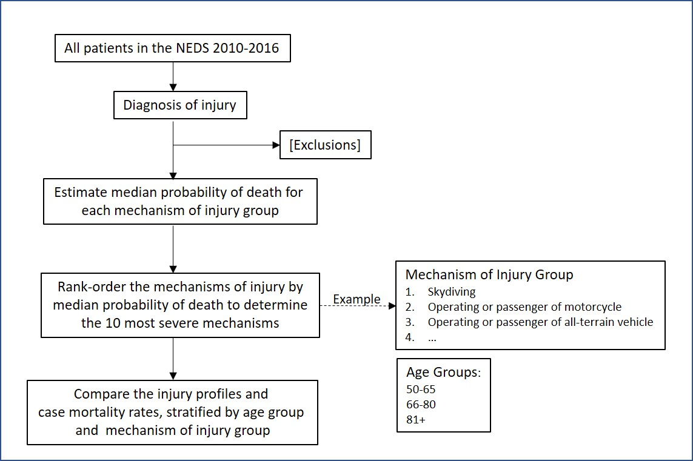

Figure 1. Scheme of study plan

**Confidentiality of Data**:

The records contained in NEDS are anonymized by AHRQ. As such the following apply:

1. The data are universally accessable

2. The data will not be destroyed

**Consent**:

Not applicable

**Risks and Benefits**:

Risks: None

Benefits: None

**Statistical Considerations**:

1. Parametric and nonparametric will be applied to test significance of differences as appropriate.

2. Multivariable logistic models for death will be hierarchical in nature, with mechanism of injury type and age group as random effect parameters

**Data variables for study**:

Age

Died in hospital

Discharge Weight

Female Sex

Patient ID across hospital visits

Patient ID distinct for each hospital visit

Primary Payer

Secondary Payer

Total Charge ED

Total Charge Inpatient

Year

Income quartile of residence zip code

Chronic conditions

Procedures

Diagnoses

External Causes of Injury and Poisoning (E-Code)

REFERENCES

1. Howden L, Meyer J. Age and sex composition, 2010. Washington, D.C.: U.S. Department of Commerce, Economics and Statistics Administration, U.S. Census Bureau; 2011.

2. Gerson L, Stevens J. Recreational injuries among older Americans, 2001. Injury Prevention 2004;10:134-8.

3. Centers for Disease Control and Prevention. 10 Leading Causes of Death by Age Group, United States - 2016. Atlanta, GA: Centers for Disease Control and Prevention, National Center for Injury Prevention and Control; 2017.

4. Osler TM, Glance LG, Cook A, Buzas JS, Hosmer DW. A trauma mortality prediction model based on the ICD-10-CM lexicon: TMPM-ICD10. Journal of Trauma and Acute Care Surgery 2019;86:891-5.

5. Glance LG, Osler TM, Mukamel DB, Meredith W, Wagner J, Dick AW. TMPM-ICD9: a trauma mortality prediction model based on ICD-9-CM codes. Annals of Surgery 2009;249:1032-9.